CONTACTS

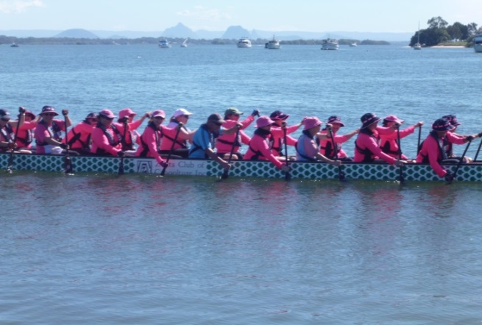
President: Mary 07 3410 7832
Mobile 0419732769
Vice President: Nan 0408194849
Secretary: Judy 07 5497 5561
Mobile 0411 2235 08
Treasurer: Carole 073410 1382 Mobile 0434 985 980
EMAIL: bribiepinkdragons@gmail.com
LOCATION Kal-Ma-Kuta Drive, Sandstone Point [behind TS Koopa building]
TRAINING TIMES
WINTER
Saturday and Monday 6.30am to be on water at 7am
Thursday 3.30pm to be on water at 4pm
SUMMER
Saturday and Monday 6am on water at 6.30am
Thursday 4. on water at 4.00pm

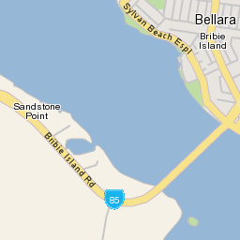
~Survivors & Supporters | ~Female & male
~New Paddlers | ~Experienced Paddlers
~All ages | ~All levels of fitness
~Social paddlers

